I can recall square numbers up to 144 and their square roots.
By the end of this half term, children should know the following facts. The aim is for them to recall these facts instantly.
A square number is a
number multiplied by
itself:
These facts are
related to the square
roots:
1 x 1 = 1
√1 = 1
2 x 2 = 4
3 x 3 = 9
√4 = 2
√9 = 3
4 x 4 = 16
5 x 5 = 25
6 x 6 = 36
7 x 7 = 49
8 x 8 = 64
9 x 9 = 81
√16 = 4
√25 = 5
√36 = 6
√49 = 7
√64 = 8
√81 = 9
√100 = 10
√121 = 11
√144 = 12
10 x 10 = 100
11 x 11 = 121
12 x 12 = 144
Top Tips
The secret to success is practising little and often. Use time wisely. Can you practise these KIRFs while
walking to school or during a car journey? You don’t need to practise them all at once: perhaps you
could have a fact of the day.
Games: https://www.topmarks.co.uk/maths-games/hit-the-button



Key Instant Recall Facts Year 5 Spring 1a

Nursery Autumn 1

I can identify prime numbers up to 20.
By the end of this half term, children should know the following facts. The aim is for them to recall these facts instantly.
Key vocabulary
A prime number is a number with no factors other
than itself and one.
Prime number
Composite
number
The following numbers are prime numbers:
2, 3, 5, 7, 11, 13, 17, 19
Factor
Multiple
A composite number is divisible by a number other
than 1 or itself.
The following numbers are composite numbers:
4, 6, 8, 9, 10, 12, 14, 15, 16, 18, 20
Children should be able to explain how they know that a number is composite. E.g. 15 is composite because it is a multiple of 3 and 5.
Top Tips
The secret to success is practising little and often. Use time wisely. Can you practise these KIRFs while
walking to school or during a car journey? You don’t need to practise them all at once: perhaps you
could have a fact of the day.
It’s really important that your child uses mathematical vocabulary accurately. Choose a number
between 2 and 20. How many correct statements can your child make about this number using the
vocabulary above?
Make a set of cards for the numbers from 2 to 20. How quickly can your child sort these into prime
and composite numbers? How many even prime numbers can they find? How many odd
composite numbers?


Key Instant Recall Facts Year 5 Spring 1b

Nursery Autumn 1

I can convert between decimals, fractions and percentages.
By the end of this half term, children should know the following facts. The aim is for them to recall these facts instantly.
= 50%
= 25%
= 75%
= 10%
= 20%
= 60%
= 90%
= 1%
Key Vocabulary
= 7%
How many tenths is 0.8?
= 21%
= 75%
= 99%
How many hundredths is
0.12?
Write 0.75 as a fraction.
Write ¼ as a decimal.
Top Tips
The secret to success is practising little and often. Use time wisely. Can you practise
these KIRFs while walking to school or during a car journey? You don’t need to practise
them all at once: perhaps you could start with tenths before moving onto hundredths.
Play games - Make some cards with pairs of equivalent fractions and decimals.
Use these to play the memory game or snap. Or make your own dominoes with
fractions on one side and decimals on the other.
https://www.topmarks.co.uk/maths-games/daily10 - Level 6 Fractions – decimal equivalents
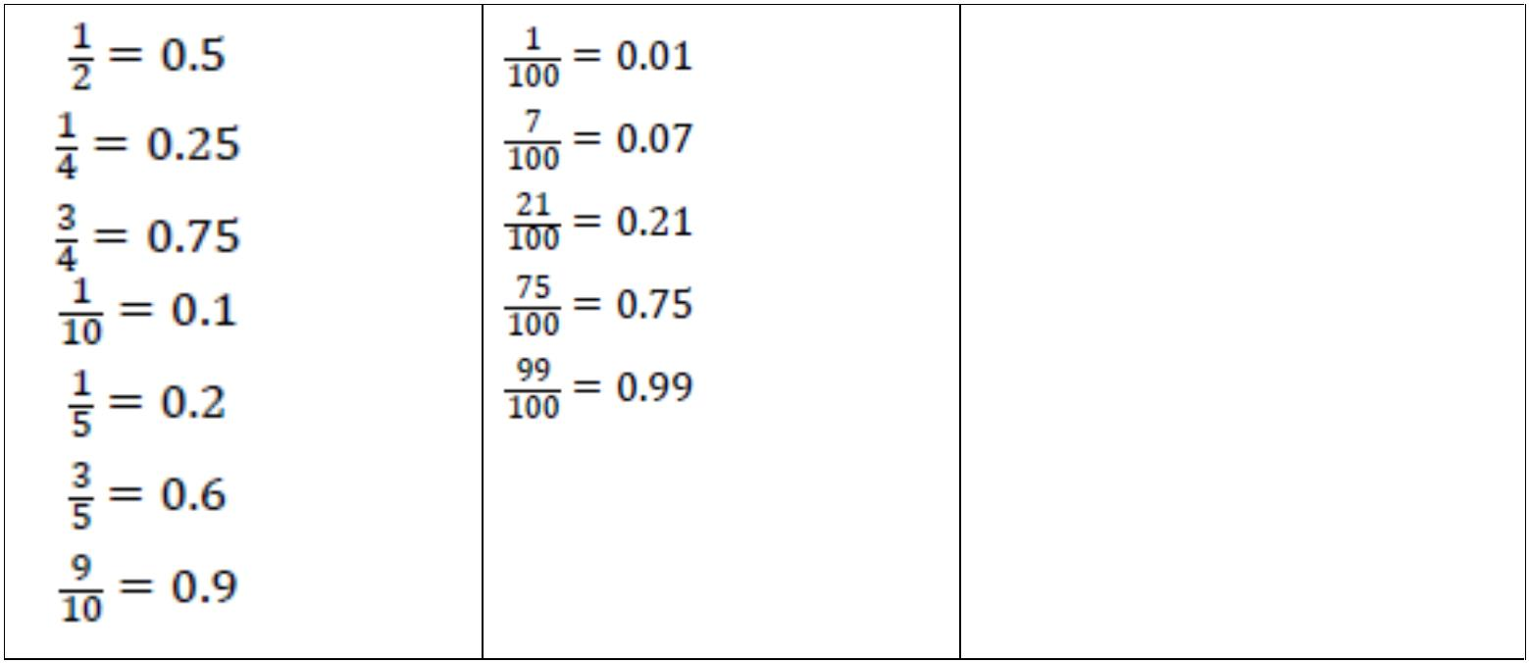

Key Instant Recall Facts Year 5 Spring 2

Nursery Autumn 1

