I can say 1 more than a given number up to 10.
By the end of this half term, children should be able to say one more than any number up to 10.
1 more than...
They might be able to record it as a calculation:
0 + 1 = 1
1 + 1 = 2
2 + 1 = 3
3 + 1 = 4
4 + 1 = 5
5 + 1 = 6
6 + 1 = 7
7 + 1 = 8
8 + 1 = 9
9 + 1 = 10
10 + 1 = 11
1 is 2
2 is 3
3 is 4
4 is 5
5 is 6
6 is 7
7 is 8
8 is 9
9 is 10
10 is 11
Use a number line to hop along one more:
The aim is for them to say the number that is one more than the number you say to them. They may be able to say what would be one less too.
Top Tips
The secret to success is practising little and often. Use time wisely. Can you practice these KIRFs while walking to school or during a car journey?
Perhaps you could have number cards that you can show your child and they say which number is one more than that number.
https://www.topmarks.co.uk/learning-to-count/chopper-squad - one more than game
https://www.youtube.com/watch?v=Du6JHupzwVo – one more song



Key Instant Recall Facts Reception Spring 1

Nursery Autumn 1

I can partition numbers to 5 into two groups.
By the end of this half term, children should know the following facts. The aim is for them to recall these facts instantly.
0 + 1= 1
1 + 0 = 1
0 + 4 = 4
1 + 3 = 4
2 + 2 = 4
3 + 1 = 4
4 + 0 = 4
Key vocabulary
add
plus
0 + 2 = 2
1 + 1 = 2
2 + 0 = 2
0 + 5 = 5
1 + 4 = 5
2 + 3 = 5
3 + 2 = 5
4 + 1 = 5
5 + 0 = 5
0 + 3 = 3
1 + 2 = 3
2 + 1 = 3
3 + 0 = 3
equals
altogether
part
whole
The aim is for them to know several pairs of numbers that make the numbers 1 to 5.
Top Tips
The secret to success is practising little and often. Use time wisely. Can you practise these KIRFs while walking to school or during a car journey? You don’t need to practise them all at once. Maybe focus on 1 number a day. How many ways can you make this number.
Use practical resources – Your child has one potato on their plate and you give them three more. Can they predict how many they will have now?
Make a poster – We use Numicon at school. You can find pictures of the Numicon shapes here: bit.ly/NumiconPictures – your child could make a poster showing the different ways of making 5.
Play games – You can play number bond pairs online at www.conkermaths.com
https://www.topmarks.co.uk/learning-to-count/ladybird-spots - put dots on the ladybird
https://www.topmarks.co.uk/Interactive.aspx?cat=1 - the story of…
https://www.nctm.org/Classroom-Resources/Illuminations/Interactives/Five-Frame/ - using a 5 frame

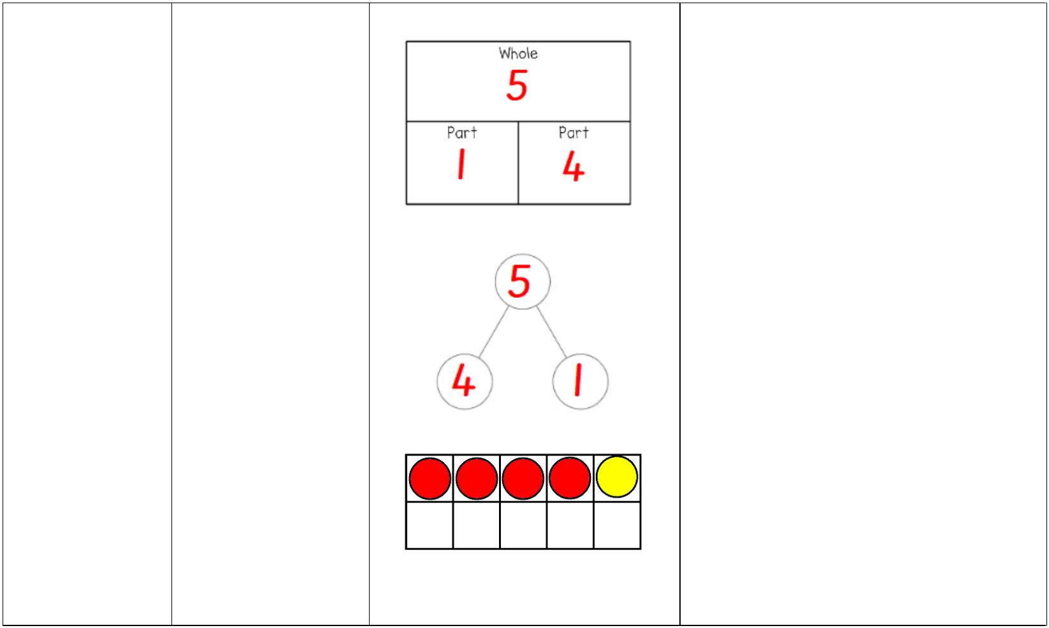
Key Instant Recall Facts Reception Spring 2

Nursery Autumn 1

