I know number bonds to 10.
By the end of this half term, children should know the following facts. The aim is for them to recall these facts instantly.
0 + 10 = 10
10 + 0 = 10
10 – 10 = 0
10 – 0 = 10
Key vocabulary
2 add 8 equals 10
1 + 9 = 10
9 + 1 = 10
10 – 9 = 1
10 – 1 = 9
8 plus 2 is the same as 10
If I have 4, how many more to get to 10?
2 + 8 = 10
8 + 2 = 10
10 – 8 = 2
10 – 2 = 8
What’s the difference
between 7 and 10?
3 + 7 = 10
7 + 3 = 10
10 – 7 = 3
10 – 3 = 7
10 take away 7 equals 3
10 subtract 3 makes 7
10 minus 9 equals 1
4 + 6 = 10
6 + 4 = 10
10 – 6 = 4
10 – 4 = 6
5 + 5 = 10
10 – 5 = 5
They should be able to answer these questions in any order, including missing number questions,
e.g. 2 + = 10 or -7 = 3.
Top Tips
The secret to success is practising little and often. Use time wisely. Can you practise these KIRFs while walking to school or during a car journey? You don’t need to practise them all at once: perhaps you could have a fact of the day.
Songs and Chants – The children should know a chant for number bonds to ten or there are chants online.
Make the whole fact family – If 9 + 1 = 10, then 1 + 9 = 10 so 10 – 9 = 1 and 10 – 1 = 9.
http://www.conkermaths.org/cmweb.nsf/products/conkerkirfs.html See how many questions you can answer in 90seconds.
https://www.topmarks.co.uk/maths-games/daily10 and https://www.topmarks.co.uk/maths-games/hit-the-button


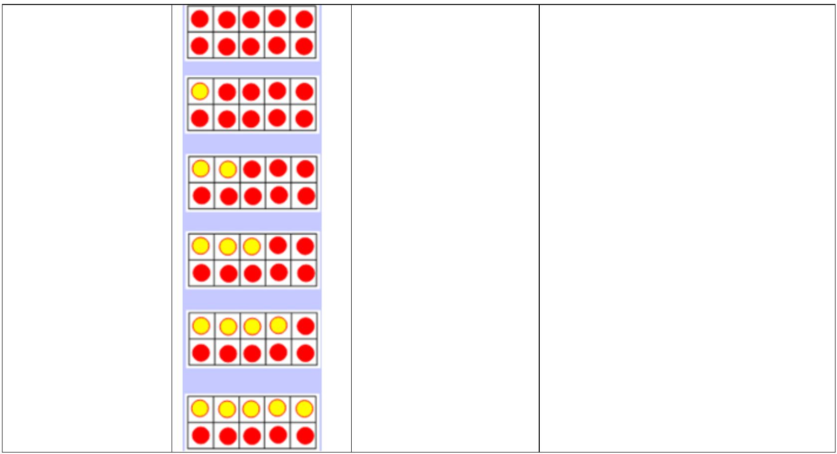
Key Instant Recall Facts Year 1 Spring 1a

Nursery Autumn 1

I know odd and even numbers to 20.
By the end of this half term, children should know which numbers are odd and which are even. The aim is for them to recall these instantly.
Even numbers:
2, 4, 6, 8, 10, 12, 14, 16, 18, 20
Odd and even
Odd numbers:
1, 3, 5, 7, 9, 11, 13, 15, 17, 19
Odd, even, odd, even...
Odd + Odd = Even
Even + Even = Even
Odd + Even = Odd
Even + Odd = Odd
1 2 3 4 5 6 7 8 9 10
They should be able to say if a number is odd or even and also be able to recall even and odd numbers.
Top Tips
The secret to success is practising little and often. Use time wisely! Can you practise these KIRFs while walking to school or during a car journey?
Write a number and identify if it odd or even.
When you see numbers out and about discuss whether they are odd or even. How do they know?
Odd/Even games: https://www.topmarks.co.uk/learning-to-count/coconut-odd-or-even
http://mathszone.co.uk/category/count-and-understand/odd-even/
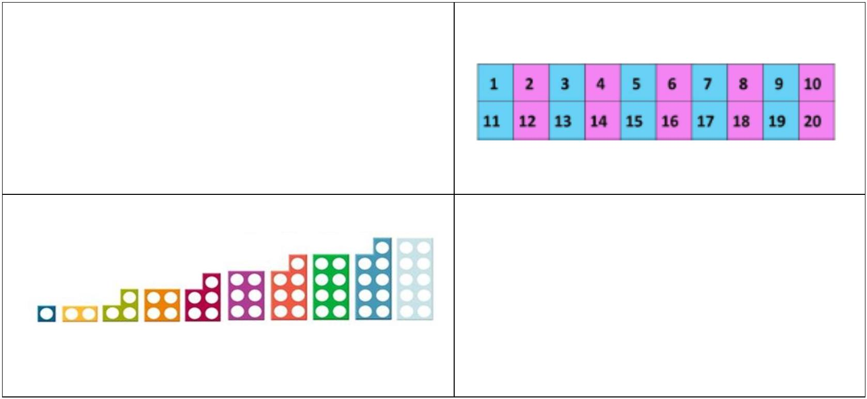

Key Instant Recall Facts Year 1 Spring 1b

Nursery Autumn 1

Count in 2s to 20. Count in 10s to 100. Count in 5s to 50.
By the end of this half term, children should be able to count in these three counting patterns. The aim is for them to say these off by heart.
Counting in twos
Counting in tens
Counting in fives
0
2
0
10
20
30
40
50
60
70
80
90
100
0 5 10
4
15 20 25
30 35 40
45 50
6
8
10
12
14
16
18
20
They should be able to count in these patterns and may be able to say if a number will be in the counting in twos, fives or tens pattern.
Top Tips
The secret to success is practising little and often. Use time wisely. Can you practise these KIRFs while walking to school or during a car journey? You don’t need to practise them all at once: perhaps you could have a week where you practise each pattern. When the children are confident with these facts can they count in 2s beyond 20 or in 5s beyond 50?

Key Instant Recall Facts Year 1 Spring 2

Nursery Autumn 1

Practise looking for number patterns with https://www.primarygames.co.uk/pg2/splat/splatsq100.html
Counting games: https://www.topmarks.co.uk/learning-to-count/paint-the-squares


