Internet Acceptable Use Agreement- KS2
These rules have been written to make sure that you know how to stay safe when using any ICT at school. This includes laptops, computers, iPads, cameras and microphones. When using ICT in school you have agreed to follow these rules.
The Golden Rule: Think before you click!
- When using the internet on any device, I will follow the SMART rules (you have discussed these in class):
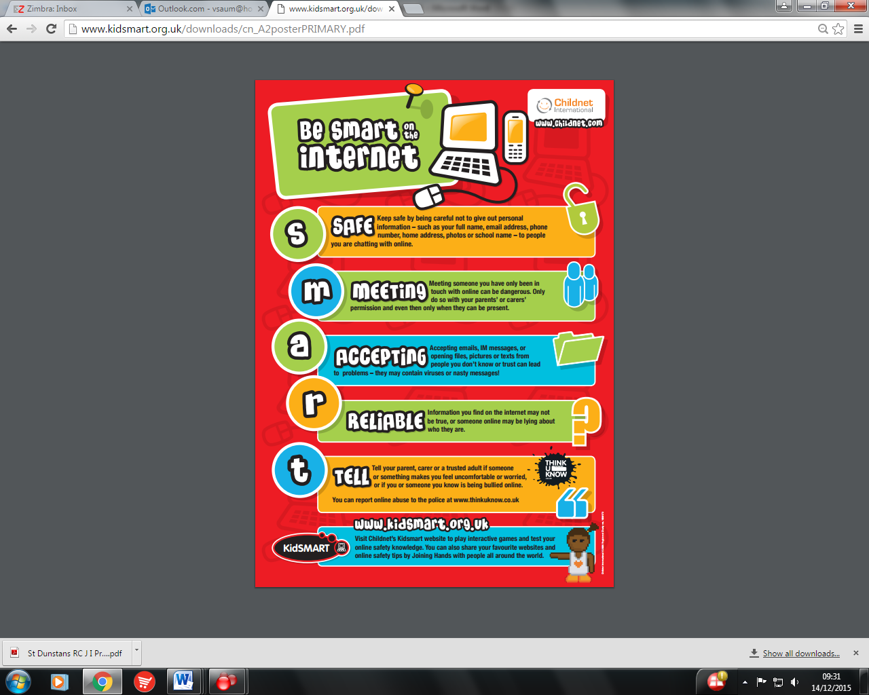
- I will keep my username(s) and password(s) a secret and never attempt to log into a resource using another person’s details.
- I understand that I am responsible for messages I send and that these may be monitored by the school.
- I will not respond to rude or threatening messages, but I will tell a teacher immediately if I receive any messages of this kind.
- I understand that things that I download (such as images, music, videos etc.) belong to someone and I will only use these in my school work.
- I will not play games (unless told to by my teacher) during lesson time.
- I will use all technology safely and responsibly in school remembering that I am using a shared device.
- I am aware that some websites and social networks have age restrictions and I should respect this.
- I will not give my home address, phone number, send a photograph or video, or give any other personal information that could be used to identify me, my family or my friends, unless a trusted adult has given permission. I will never arrange to meet someone I have only ever previously met on the Internet, unless my parent/carer has given me permission and I take a responsible adult with me.
I understand the above rules and agree to follow them. I understand that if I break these rules any incidents will be recorded and that my access to the Internet and school ICT may be stopped.
Name: Class:
Date:
As a parent/ guardian, I agree to keep my child’s details secure and to support them in following these rules.
Signature of parent/guardian:

